Python notebook (Jupiter)

Offline on your browser
Need to download
upload any notebook
Offline compiler
does not provide with AI as it is offline

Need to download anaconda
Anaconda navigator
Anaconda PowerShell prompt CLI

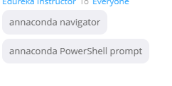

Most libraries are already included in anaconda

Best compiler in the market (anaconda and colab)

Google Colab ---> Online no need to download packages

Has its own AI
Shift ! Enter

#print sum of two numbers

